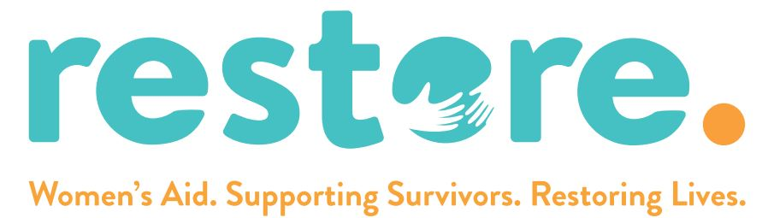

ANNUAL REPORT 2024/2025
Registered Charity No. 276883
Company Registration No. 1338724

INTENTIONALLY BLANK

CONTENTS

PHILOSOPHY STATEMENT 5
OUR AIMS 6
DIRECTORS/TRUSTEES 7
PATRON 8
CHAIR OF TRUSTEES REPORT 9
PRINCIPAL OPERATIONS MANAGER’S REPORT 12
SUPPORT SERVICE MANAGER REPORT 18
YOUNG PERSONS’ SUPPORT REPORT 21
FINANCE MANAGER REPORT 31
FEEDBACK 36
ACKNOWLEDGEMENTS 37
DONORS AND SPONSORS 39
SPEAKING ENGAGEMENTS 40
CURRENT SERVICES 40

INTENTIONALLY BLANK

PHILOSOPHY STATEMENT

Domestic Abuse is Unacceptable
Domestic abuse, in all its forms, impacts upon ordinary people and their families and experiencing it will always be traumatizing. The women, men, children and young people we support, both in our Refuge and through our Outreach Services, will be offered a non-judgmental service tailored to their individual needs. We believe that those impacted by domestic abuse need assistance, support, trust and a feeling of safety delivered in an honest, transparent and trauma informed manner.
We will offer practical and emotional support to all and understand that the children who have lived in situations where there is domestic abuse, have also been affected by it and their needs may require addressing separately. The traumatic experience of living with domestic abuse is often surrounded by other complex issues that we will help our clients and residents to address. RESTORE Women’s Aid believes that we need to take a holistic approach or order to empower our clients, our residents, and their children to live a life free from domestic abuse.

Vision: To live in a society where domestic abuse is unacceptable
Mission: To provide a safe, empowering and person-centred service to anyone who has experienced or is experiencing domestic abuse.
Values: To work alongside people who have experienced domestic abuse with honesty, respect, trust and fairness.

This idea of our organisation as a growing, living thing has become part of the business plan. It shows how new funding could be added at the roots to provide new branches which in time will bear fruit.

OUR AIMS

- to provide temporary accommodation at our Refuge for women* and their children who are fleeing domestic abuse also, to support these people as they settle into their new community
- to meet the needs of children and young people affected by Domestic Abuse through a dedicated Children and Young Person’s Service
- to facilitate community-based education programmes that enable people to better understand the behaviours of an abuser and to empower them to take control of their own future
- to offer support and advice through our Helpline and Outreach Service to any person who asks for it
- to raise community awareness of Domestic Abuse issues and of the services we offer
- to provide therapeutic support to all survivors of domestic abuse who are using our services
- to provide practical support to people who have experienced domestic abuse.

*The refuge is a service for females only and males up to the age of 16, as is legislated for under the
Equality Act 2010, Part 7, Paragraph 27 on single-sex spaces

DIRECTORS/TRUSTEES

Chairperson | Nicola Iannelli-Popham
Vice Chair & Company Secretary | Fiona Harbron
Treasurer | Elizabeth Larcombe
Trustee  Trustee | Charlene Boyaram  Jackie Burnett
Trustee | Sue Dearman
Trustee | Christina Dye
Trustee | Pat Leach
Trustee  Trustee | Siobhan O’Neill  Hannah Stammers
Trustee | Harry Badman (co-opted)

PATRON
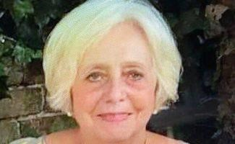

Jeannie Bloomfield

I start my report this year by saying it’s now 50 years since we started offering our services to vulnerable women and their families who are victims of domestic abuse.

It’s been an extra busy time for our staff and volunteers as we have now moved to more suitable and accessible premises for staff and clients. There is a lift installed for women with pushchairs and to make it easier for our disabled visitors.

I have enjoyed playing a small role by fundraising and giving talks to raise awareness of the help we offer for our vulnerable families.

Being a former victim of abuse, I have enjoyed helping and attending our SODA (Survivors Of Domestic Abuse) group and coffee mornings to keep our ladies’ spirits up and it also gives them the opportunity to encourage each other now that they have started to have a life free from abuse.

I also let people who attend my talks know about what’s on offer at our refuge and how our qualified and caring staff and volunteers help victims start to feel safe again.

I have been fortunate enough to be accompanied by two members of staff and a volunteer who are passionate about their role in looking after our families, by making them feel safe and positive not just in our refuge but when they leave to start their new lives too.

We have been planning several meetings this year to help celebrate our 50th Anniversary with a calendar of events. This will run over a 12-month period, starting from November 2024 but we have started preparations early!

I feel very proud to play a small part by being involved with such a fabulous group of dedicated people who give vulnerable women hope and encouragement to move on to a better life.

CHAIR OF TRUSTEES REPORT
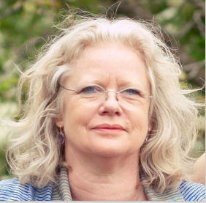
Nicola Iannelli-Popham
2024-25 has been another challenging year for our organisation. Our long-standing Trustee and past Board Chair and then Vice-Chair, Maureen Byrne, resigned from the Board and has been replaced as Vice-Chair by another long-standing Trustee, Fiona Habron. Our other much valued Trustee, Jean Staff, sadly also resigned in November but the newly created Trustee Recruitment and Training Subcommittee was able to recruit a young man, Harry Badman, who will be confirmed as a Trustee at the 2025 AGM. We have no doubt that his experience with financial advice and fundraising will be of great value in the future.
This year has seen us move forward with our rebranding plans and, although our legal name remains Bury St Edmunds Women’s Aid Centre Ltd, we decided on the new operational name of Restore Women’s Aid, standing for Respect, Empathy, Support, Trust, Outreach, Refuge and Empowerment. This was approved at the 2024 AGM in July and officially launched in November, on White Ribbon Day. The new name is the result of much collaboration and discussion between Trustees, staff, our volunteers and, importantly, our clients and residents.
As a result of the decision to rebrand, it has been necessary to update and revise our website and thanks go to our Media Lead Trustee Sue Dearman and to Christopher Allen who have worked tirelessly to produce a new, more interactive, relevant and up to date website. Many thanks are owed also to Andy Connacher, the owner of Whitewater Graphics, for his and his staff’s invaluable help in the design and production of all our rebranding materials.
Over the year we have established some new Subcommittees – the Trustee Recruitment and Training Subcommittee and the Volunteer Recruitment and Training

Subcommittee. The purpose of all our subcommittees is to make our processes more transparent and effective, and it was my aim to ensure that all Trustees feel involved and appreciated for the time and effort they put in as members of the Board by providing them with a greater number of options for participation. All Trustees have also attended the staff meetings held on a fortnightly basis on rotation, providing feedback to staff about the Board and its decisions and about the organisation’s workings to the other Trustees at Board meetings. In addition, all Trustees have now gone through certified Equity, Inclusion and Diversity training.
The year began with starting preparations for our 50th Anniversary as the Bury St Edmunds Refuge was first set up in 1974 by Sheila Wormleighton and others who had been inspired by the ‘Battered Wives Movement’ and the creation of the national Women’s Aid organisation, also in 1974. We have grown immensely since that day when one woman and her son were helped into a safe place to escape the domestic abuse to which they had been subjected. Our current Refuge can house up to 8 women and 11 children. The Outreach service, which works with women, children, young people and now also men, has expanded this year to cover not only Bury St Edmunds and Haverhill but Newmarket and Stowmarket.
In order to recognise and celebrate our 50th year, we planned a series of monthly events and, by the end of 2024-25 we had held a launch event in November at our Malthouse offices, on White Ribbon Day, which included the presentation of a splendid, permanent artwork that was kindly created and donated by a local artist, Deborah Pipe. In February 2025, the Bury St Edmunds Theatre Royal put on the screening of a short film that had been created in collaboration with some of our clients who helped to write the script and provide the inspiration and ideas for the production. The resulting film screening was both deeply moving and a powerful message about the effects of domestic abuse and how people can overcome the trauma they have experienced. In March, some hardy supporters participated in the Bury St Edmunds Rotary Club’s Swimarathon, raising the splendid sum of £410 for Restore.
Also in March 2025, Restore Women’s Aid was honoured to receive one of the High Sherriff’s awards at a ceremony held at the Apex. Katherine Ahluwalia, our Principal Operations Manager, and I had met with the High Sherriff not long after she took up

the role as we asked her to assist us in ensuring that family court magistrates receive greater training and a better understanding of domestic abuse and its effects on families as we had become aware of the poor outcomes many of our clients and residents were experiencing. As a result of this meeting, progress is now being made in this field and we are extremely grateful to the High Sherriff, Yvonne Gilchrist-Mason for her understanding, help and support.
2024-25 has not been without its own financial challenges but, due to the hard work and diligence of our Fundraising Subcommittee, our Finance Officer, our senior management team and all those involved with Restore – as well as to generous donations and support from outside the organisation – the situation has now turned around, and we are ending the year on a very positive note. Our staff continue to provide an excellent service to all those who use our services, both in the Refuge and our Domestic Abuse Community Hubs.

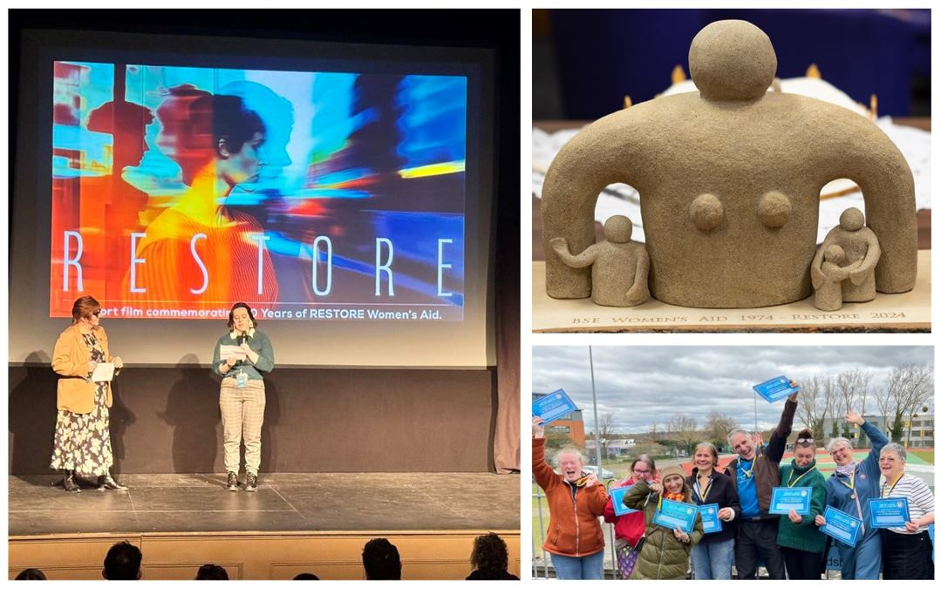

PRINCIPAL OPERATIONS MANAGER’S REPORT
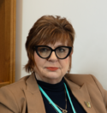
Katherine Ahluwalia
Reflecting on the last year in terms of our successes is an important process, particularly as it has been a major year for us as an organisation and for our development.
Here are some of our Highlights:
Rural Community Domestic Abuse Hubs
In June 2024 we continued to extend our reach into the more rural communities in West and Mid Suffolk. Following on from successful funding applications and extensive research, we opened two new Domestic Abuse Community Hubs in Newmarket and Stowmarket, offering a wide range of specialist services to support these local communities. We now have community based domestic abuse hubs in Bury St Edmunds, Haverhill, Newmarket and Stowmarket.
As part of our research, we observed community-based work taking place in the rural towns in Suffolk, however this was accompanied by a deficit in local domestic abuse services and major issues with the lack of public transport and prohibitive costs for clients, creating more barriers to accessing this kind of specialist support. Presentations on our objective to provide community-based domestic abuse hubs in rural areas was met with overwhelming support from other local organisations, including local authorities, as the desperate need for these services had become abundantly clear.

We have become an active member in the local partnership forums where we update all the participants on the developments in our services. We also connect these professionals with our project co-ordinators and refer their clients onto our services.

New professionals and organisations are joining these forums all the time so we will continue to widen our reach and strengthen our professional networks.
We have also expanded our work to support male survivors of domestic abuse, as they are poorly served and suffer additional barriers and stigma attached to accessing specialist support. Following research, and in collaboration with a local mental health charity and the IDVA Service (Independent Domestic Abuse Advisors), we have set up a Men’s Drop-in session and written an online Men’s Domestic Abuse Recovery Programme. We are continuing to shape and develop this service in line with feedback from these survivors.
50th Anniversary Commemorations
As part of the commemoration of our 50th Anniversary of having a Refuge in Bury St Edmunds we developed a calendar of events to run throughout the year, starting in November 2024. Some of the highlights and upcoming events include:

- Our name change and our re-branding which was provided free of charge by a local marketing agency
- A new Website designed and managed free of charge by a local web designer
- The establishment of our Adult and Young Ambassadors programme
- A social media campaign highlighting the work we do and fundraising opportunities
- The production of a film in collaboration with the Theatre Royal which included creative writing workshops and a private screening at the theatre
- We commissioned a permanent artwork by local artist Deborah Pipe
- A 1970’s themed Afternoon Tea Party in August
- A Creative Show Case in July being produced by Abbeygate 6th Form College incorporating fashion design, photography, media and artwork
- An Experts in Lived Experience Conference in October

We are planning to build on the publicity and awareness raising this commemorative year has generated for our organisation.
The High Sherrif’s Award
Following on from some concerns we had about the outcomes we were seeing in the court system we contacted our High Sherriff to start discussions to amplify our clients’ voices. This resulted in us receiving the High Sherrif’s award, a small grant as well as publicity about our services. This unique award is presented to organisations who have made significant contributions to their communities or have gone above and beyond to assist in bringing someone to justice or helping a victim of crime. We were honoured to receive this award.
Children and Young People’s Service
We have continued to expand our Children and Young People’s Service into local primary schools, secondary schools and colleges. We were delighted to attend Crucial Crew in June 2024 delivering Healthy Relationship Education to over 700 year 6 pupils. We will be delivering Crucial Crew again this year and the numbers of pupils registered to attend is already over 1,300. This work is so important with the Domestic Abuse Act (2021) which for the first time recognises that children living in homes where there is domestic abuse are indeed victims in their own right.
Extending Our Counselling Service and Clinical Supervision
For some time, we have been aware of the need to extend our mental health support services to our clients as many of them experience mental health challenges due to the impacts of trauma resulting from domestic abuse. We now offer a fully funded trauma-informed counselling service where we triage our clients to either a British Association for Counselling and Psychotherapy qualified, registered experienced professional counsellor or one of our final year degree students from Suffolk University who complete their placements with us. Our counselling service is available in all our Domestic Abuse Community Hubs across West and Mid Suffolk.
Due to the nature of the work we undertake, our Team is very suspectable to vicarious trauma, so we provide regular Clinical Supervision to all staff to try to mitigate the

impact of working with trauma on a daily basis. Staff wellbeing is at the centre of our organisation, and we believe this contributes to the stability and resilience of our staff team. It is important that all our staff to feel valued, supported, and able to work to their full potential. We now have annual Wellbeing Days, staff have a wellbeing hour every month and we are working towards our Good Health at Work award, funded by Suffolk County Council.
Improved Governance
Good governance is fundamental to our charity’s success. It enables and supports our compliance with the law and relevant regulations. It also promotes a culture in which everything works towards fulfilling our vision.
In the last year we have improved our governance by continuing to develop our sub-committees in key areas, for example, HR, Policies, Business Planning, Fundraising, Trustee Recruitment and Succession. We have also improved the communication pathway between staff and Trustees so for example, we have a rota of Trustees to attend our Staff Team Meetings to give an update on the work they do and to get feedback from the staff.
Professional Development
We are committed to being a Learning Organisation so in line with this ethos, we actively encourage our Team to engage in relevant training opportunities. In the last year we have participated in:
Formal inhouse training sessions, such as Staff Sharing Best Practices. We also delivered training workshops on: The Impacts of Domestic Abuse on Mental Health; Coercive Controlling Behaviours - the Research and the Survivors' Perspective; and Trauma Informed Practice.
Our staff, volunteers and Trustees all access the Suffolk Continuing Professional Development service for training in Domestic Abuse Champions, DA Risk Assessment, Safeguarding - Adults and
Children, Equality Diversity and Inclusion, Harmful Practices, Self-harm, Gangs and Youth Violence, Hate Crime, Honour-Based Violence, Health & Safety Training, etc.

All our staff are Adult and Children First Aid Trained and KUF (Knowledge and Framework) Trained which is for professionals working with clients who have Complex Emotional Needs and Personality Disorders.
All Staff, volunteers and Trustees are completing a certificated EDI programme.
We circulate numerous free training events to all our team; this includes training on Mental Health, Sensitive Conversations, Healthy Relationships, Mult-Agency Safeguarding Forums, Understanding Neurodiversity, Training for Youth Workers and more.
Promoting our Services
We are determined to increase the awareness of the impacts of domestic abuse to professionals and our communities. We have delivered numerous training workshops and presentations to local community groups, businesses, professional forums and networks, housing providers, statutory agencies, and at various AGMs to help to inform professionals of the impacts of domestic abuse, its signs and how to refer survivors onto a pathway of specialist domestic abuse advice and support.
Funding Successes
We are delighted that the last year has seen an improvement in the success of our funding applications, including the latest funding from the National Lottery. We are going to continue to build on this success and to diversify our fundraising strategy by, for example, accessing corporate funding.
All these developments have evolved over the year aided by client and staff feedback. We will continue to build on our successes in the coming years moving forward from strength to strength.
Challenges
As well as recognising and celebrating our successes we also have to consider the challenging times we are operating in. Despite the ongoing concerns about funding, financial resilience, and workloads, we are achieving our goals.
The economic downturn has resulted in lower disposable income for many individuals and families which means charitable donations have seen a significant decrease for many smaller charities like ours.
Austerity measures have also seen some funding cuts, as well as budget reallocations. Nonetheless, violence against women and girls is still a priority sector. This all means we have had to be creative and proactive in filling the gaps in our funding.
Like many others, we have also seen the rising costs of goods, services, salaries and utilities all of which have strained our budgets while, at the same time, the demand for our services have increased, particularly as a result of the cost-of-living crisis. More people are relying on food banks, mental health support, and housing assistance provided by charities like ours which are experiencing reduced income while still needing to meet this demand.
Despite this economic backdrop, we are optimistic about the future for the organisation, our employees, our volunteers, Trustees and, above all, for all the women, children, young people and men we support on a day-to-day basis.
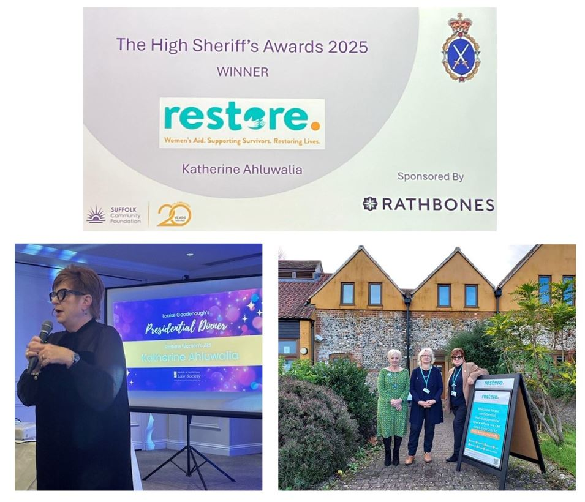

SUPPORT SERVICE MANAGER REPORT

Zoe Gordon

Having just completed two years in this post, I look back over the last year and wonder where it has gone! There is always so much to do and so much happening.
Just at the start of the year Katherine and I found out that we had passed our Support Services Management Training, giving us both a level 4 accredited qualification. Staff have attended several training sessions, as always, and have learned about a variety of subjects including faith-based abuse, how to support survivors in the deaf community, hidden harmful practices and trauma focussed sessions. We have also increased our knowledge around cyber threats and learned how this emerging technology is being exploited by perpetrators.
This year has again seen refuge occupation peak and trough. We have seen a further increase in clients presenting with complex trauma both in refuge and at our outreach services.
Our refuge building has undergone various cosmetic improvements with Denbury Homes giving both their time and providing materials to decorate our very long hallway and a couple of other rooms. This voluntary help is invaluable as staff have neither the time nor the resources to carry out this work.
We have now settled into our Outreach premises in Malthouse and the extra space and light rooms have been very welcome and made a big difference to us all. We have worked closely with Steam House, who are situated in the same building as us, to provide a multiagency approach with referrals regularly being made between us.

This year saw the launch of two new hubs; Stowmarket and Newmarket. Both host weekly coffee mornings and have provided VOICE (Victims Of Intimate Coercive Experience) programmes, with more to come.
Alongside coffee mornings and empowerment groups we are now also able to provide counselling in each area, to increase the number of clients able to access this vital service.
This year Katherine and I began a collaboration with Good Health at Work, a Suffolk County Council funded initiative aiming to improve health and wellbeing of the working population in Suffolk. Working closely with our GH@W ambassador Laura we are investigating various ways of looking after the wellbeing of our staff and volunteers as part of our commitment to them. The work we carry out is enormously rewarding but also difficult, challenging and emotional. By doing all we can to look after our own wellbeing we are also ensuring our survivors receive the very best support from us.
As always, a huge thank you from me to our amazing staff, volunteers, trustees and patron. One of our outreach team described us as “small but mighty”, and I think this encapsulates us perfectly!

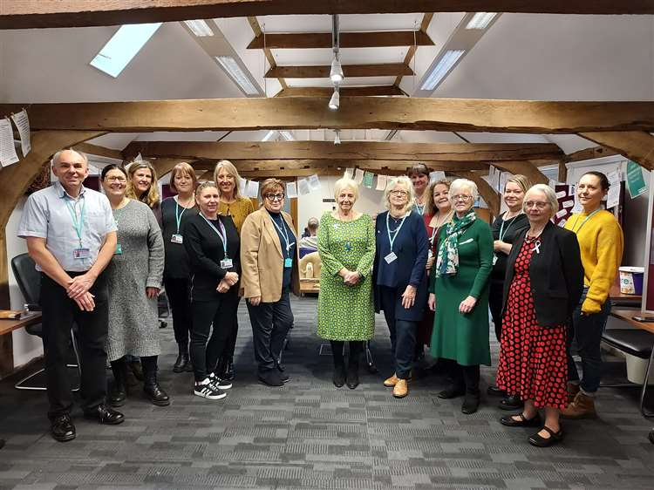

REFUGE SUPPORT STAFF REPORT
Alison Chambers and Victoria Pestell

During the last year, the refuge has been home to 23 women and 19 children. We are pleased to have been able to help as many people as we have.
Refuge staff continue to have weekly catch-up meetings as a debrief of any recent events and check in for the upcoming week. This is a useful way of fully understanding all our current residents, rather than just our own caseloads. It enables us to prepare for potential issues and be aware of what assistance our residents may require.
Victoria has recently increased her working hours which is proving to be valuable for both her refuge and resettlement clients. It also allows Victoria and Alison to work more closely together to ensure all of the clients’ needs are met.
Over the past year, we have had a number of more complex cases in refuge which have been a steep learning curve and required us to approach our work flexibly. We have had to gain a greater understanding of translation services, immigration and more in-depth housing issues.
We have now delivered our first ‘Power to Change’ group. This was with a group of refuge residents with whom we had already built good relationships through our roles as their support workers. It enabled us to gain honest feedback from them and get their ideas not only what they want from an empowerment group, but also on what they felt were the most useful topics to cover.
Alison now has regular meetings with the domestic abuse link worker at West Suffolk Council who also attends our refuge house meeting bi-monthly. The residents have found this very useful as housing is often one of their main concerns whilst living in refuge. This working relationship also helps with a more seamless transition into our resettlement service.

YOUNG PERSONS’ SUPPORT REPORT
Louise Mullan

Training and Development
This year I completed a range of relevant training, including the new E-CCard scheme (free condom scheme), young people’s mental health, having difficult conversations and sessions on incels and misogyny. I also attended Safe Lives, What Has Happened to You Now, and the Youth Focus Conference, all of which enhanced my trauma-informed and youth-centred practice.
Events and Outreach
I attended several well-attended events, including freshers’ fairs at West Suffolk College and Abbeygate Sixth Form, where I promoted our services and ran an interactive healthy relationships quiz. I also joined well-being events in Stowmarket and Haverhill, which helped raise awareness and strengthen local partnerships.
A highlight was involvement in Crucial Crew at West Suffolk College, where we delivered RESPECT sessions to around 700 Year 6 students alongside other local services.
One-to-One Support
Referrals from schools have continued steadily. I have supported young people affected by domestic abuse or unhealthy relationships and helped them recognise red flags, set boundaries, and understand what healthy relationships look like.
Group Work and Drop-ins
Although most drop-ins have been quiet, the monthly session in Haverhill remains effective. I am exploring new Girls’ Empowerment Groups and plan to reintroduce monthly drop-ins.
Group work has expanded this year. I have delivered multiple Escape the Trap sessions, including one for 18–24s at our outreach centre and a successful group for boys in Haverhill. I have also continued offering Expect Respect to schools.

School-Based Education
I led two drop-down days at County High School on consent, sexism, and healthy relationships, reaching 120 students. I also delivered tailored sessions at Beyton Sixth Form and Culford School, receiving very positive feedback.

“Thank you again for running such an incredible workshop. I have had so much positive feedback; the girls really benefited from it and found it valuable.”

Conclusion and Looking Ahead
2024 has been a rewarding year, with impactful outreach, education, and support for young people across the county. In 2025/2026, I aim to grow our group work, improve drop-in access, and strengthen early intervention efforts.
We are also excited about a new partnership with the Theatre Royal and look forward to co-developing a creative project to engage young people through the arts.

Our Young Ambassadors: Voices of Strength and Change
Over the past year, I have had the privilege of supporting an incredible group of young people — our Young Ambassadors. These inspiring individuals have each experienced domestic abuse, either in their own relationships or within their home environments. Their courage in sharing their stories and using their voices for change is nothing short of remarkable.
Recently, we took a special trip to Norwich for a photo shoot — a moment to capture not just images, but the strength, resilience, and unity of these young ambassadors. It was more than a photo session; it was a celebration of how far they have come and a powerful reminder of why their voices matter.
Our Young Ambassadors Programme exists to empower survivors and to ensure that young people who have lived through abuse are not only heard but seen as leaders of change. They are already planning to join us at future events, helping to shape

conversations around domestic abuse and influence how services and support are delivered.
As we mark our 50th year, our ambassadors have been a vital part of the celebrations — reminding us that while our past is built on years of advocacy and support, our future is in the hands of bold young voices who are ready to lead with lived experience, honesty, and hope.
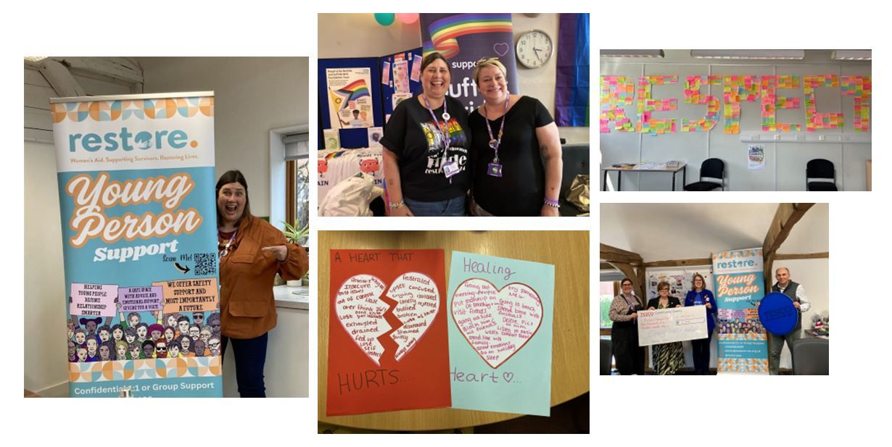
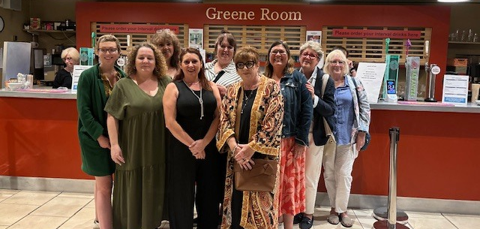

CHILD SUPPORT WORKER REPORT
Sarah Hart and Sophie Hickmott

Over the past year, our children's services have made significant strides in supporting vulnerable children and families across West and Mid Suffolk. Through a combination of therapeutic interventions, community engagement, and professional development, we have worked to create a positive impact.
Engaging Children Through Therapeutic Arts and Community Activities
During the summer holidays, we provided six therapeutic arts and crafts workshops, attended by 11 children from our outreach services. These sessions aimed to offer emotional support and creative expression, helping children process their experiences in a safe environment. Additionally, we organised a series of family outings for those residing in our refuge, including trips to the beach, a splash park, a picnic in the park, bowling, and Tostock Animal Farm. For our outreach clients and their children, we hosted fun days featuring arts and crafts activities and group picnics. These events were to build community connections, offering families a supportive network through the holidays while the programmes were not running.
Expanding Therapeutic Support: Drawing & Talking and Helping Hands Programmes
Both of our children's support workers have undergone training in the “Helping Hands” programme, enabling them to run three active groups, including one in a local primary school. This programme focuses on building resilience and emotional literacy among children, equipping them with tools to manage their feelings and behaviours. In addition to group work, our support workers are providing one-on-one therapeutic interventions using the Drawing & Talking method. This approach allows children to express complex emotions through art and sand play. The demand for this service has been growing, we are receiving more referrals from a wider area, now that we have established hubs in Newmarket, Haverhill, and Stowmarket.

Wildlife and Outdoor Learning area
Over the past couple of years, we have been planning and developing an outdoor learning and wildlife area This project has been supported by our partnership with the Suffolk Wildlife Trust. They provide a wealth of ideas for outdoor activities that engage the children, and their understanding of the natural world.

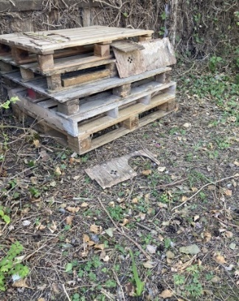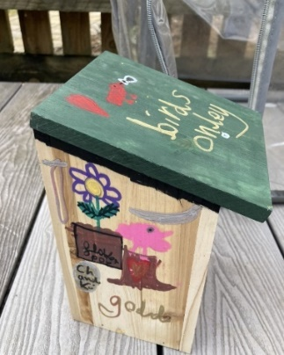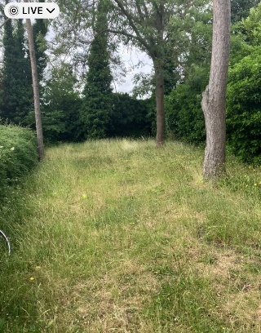

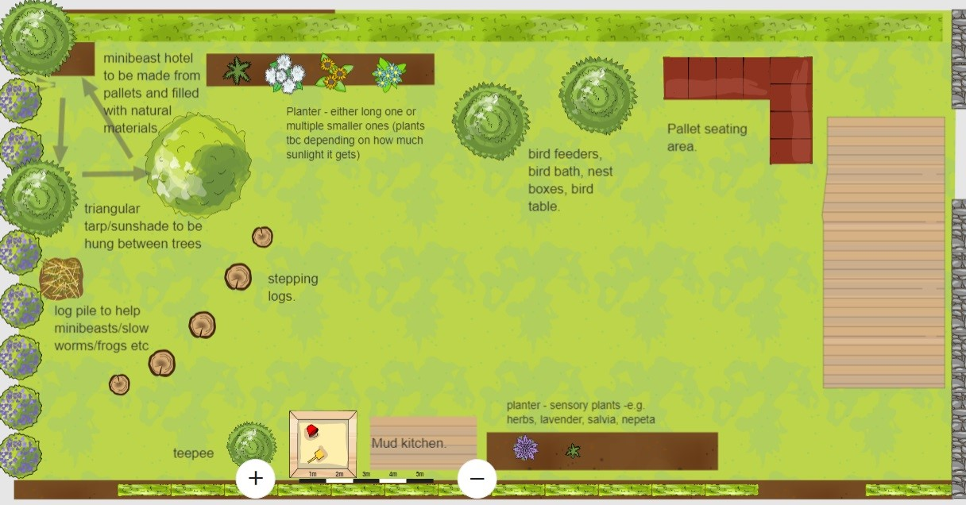

Who's in Charge Programme
Looking ahead, both of our children's support workers have recently completed training to facilitate the Who's in Charge programme. This programme is to support parents of children displaying challenging or abusive behaviours towards their parents. We anticipate launching this programme in September 2025.
Recognising Children as Victims of Domestic Abuse
At Restore Women's Aid, we are committed to recognising and addressing the unique needs of these children. Our services provide a safe and supportive environment where children can express their experiences and begin the healing process. Through our interventions, such as the Drawing & Talking method, and emotional support, we aim to help children rebuild their sense of safety, self-worth and trust. By acknowledging their experiences and offering tailored support, we empower these children to overcome the trauma of domestic abuse and work towards a healthier future.
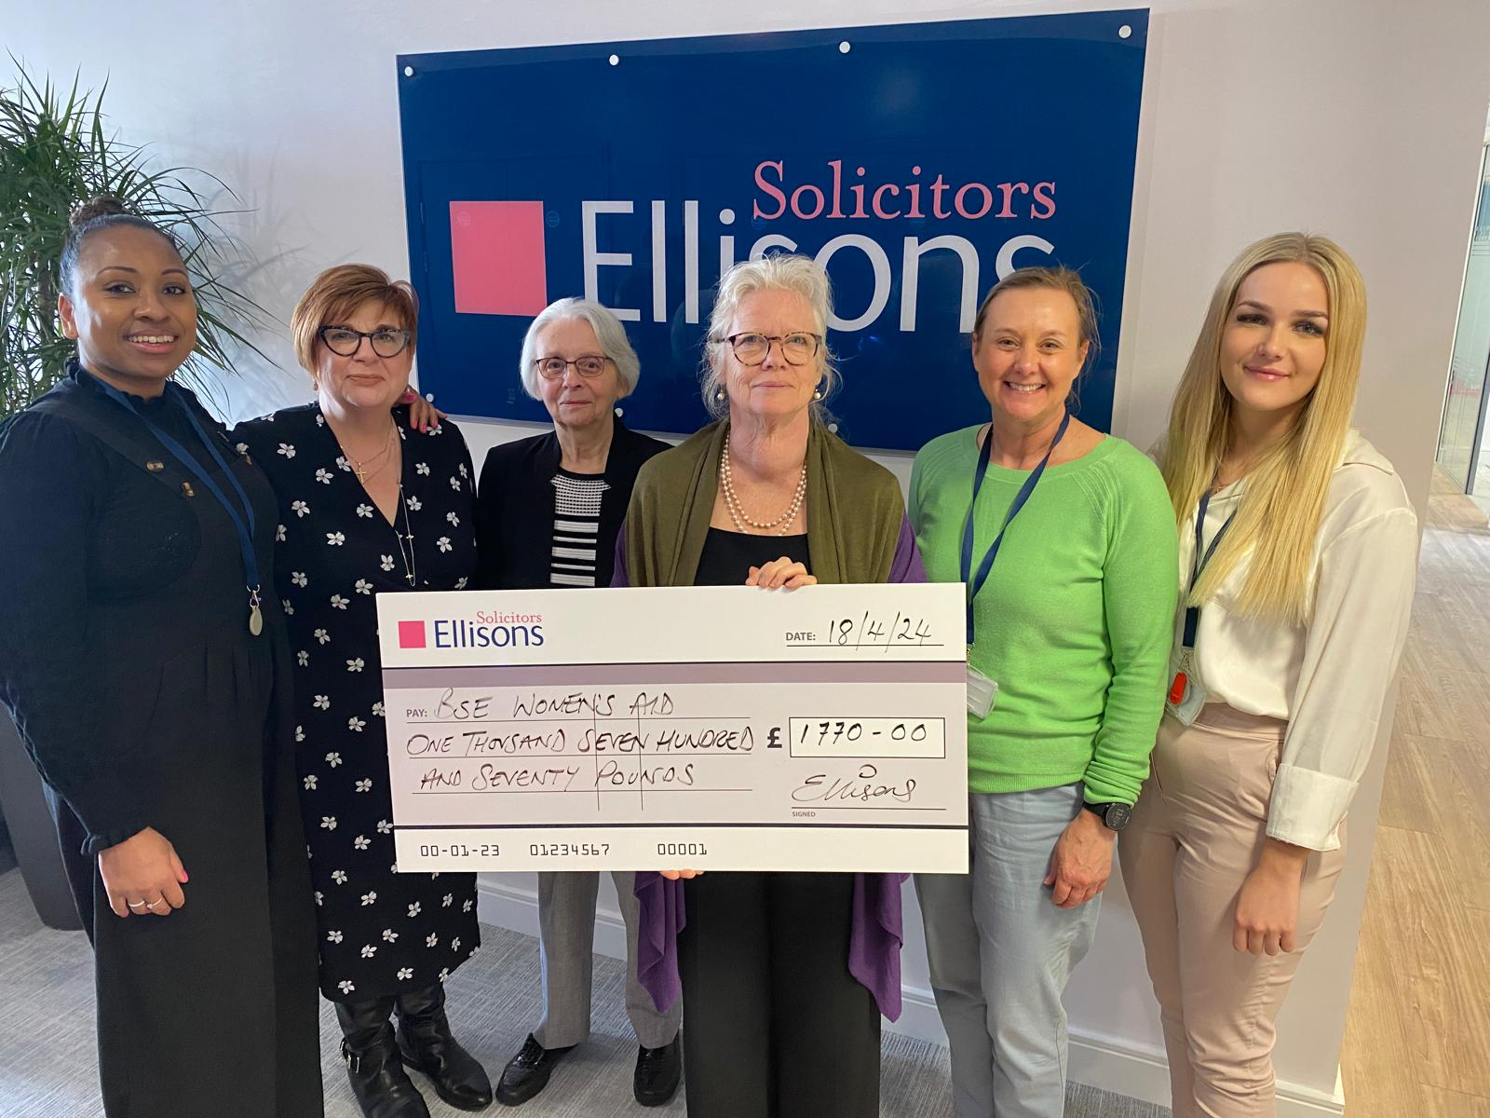

OUTREACH SUPPORT WORKER REPORT
Tracy Harvey, Lee-Ann Lummis and Ellie Phipps
Our team has continued to work successfully together across West and Mid Suffolk, with face-to-face access to our services available in Bury St Edmunds, Haverhill, Newmarket and Stowmarket.
As a team, we work hard to ensure the client is contacted to discuss the services we provide and how we can make sure their needs are met. This may be via our coffee mornings, Freedom programme, SODA (survivors of domestic abuse), V.O.I.C.E (Victims of Intermit Coercive Experience) or the outreach service.
Coffee Mornings
Having added two new hubs to our service in the last year, coffee mornings currently run in Bury St Edmunds, Haverhill, Newmarket and Stowmarket. They offer women who have experienced domestic abuse a safe space to come and meet other women who may have had similar experiences.
In 2024 we moved our Haverhill location from the Eastern Centre to the Arts Centre. This proved to be the right decision as the new location suited us more for our outreach needs and offered a better space for childcare.
Coffee mornings are a vital part of many of our client’s weekly routine and offer them some self-care by relaxing, getting advice, joining in with crafts and building a support network. We often tell our clients that it's not always about what happens during the sessions but about empowering them to do something for themselves and getting through the doors. This is a huge task for many and not as easy as it sounds.
With the opening of the new hubs in Newmarket and Stowmarket and the increase of referrals received from GP Social Prescribers and Housing Officers, we have seen cases continue to grow - which is proof of how vital our service is.
May we take this opportunity to thank our volunteers, who have made our coffee mornings possible over the last year.

V.O.I.C.E
V.O.I.C.E programme is a 12-week programme that has run successfully in Bury St Edmunds and Haverhill and, during the last year, has started in Stowmarket and Newmarket.
This programme is interactive and focuses on a variety of learning styles using discussion, self-reflective exercises, visual media and active participation to generate learning for all participants in a supportive, regulated and trauma informed session. Louise (Young Person Outreach Support Worker) has done an amazing job, continuing to help clients, by delivering the programme and supporting them often with other needs as and when they arise.
Freedom Programme
Our Freedom programme continues to be in demand and due to this, has now become a rolling programme. This allows clients to quickly access the programme to learn about domestic abuse and make sense of and understand what has happened to them. The programme helps survivors to recognise potential future abusers and encourages women to gain self-esteem as well as building confidence to improve their lives. We get such amazing feedback from clients who have attended, often not realising that what they have experienced is abuse.
SODA
Our SODA group continues to thrive and increase in numbers, offering focused support and guest speakers which empowers our clients even further. We ran a slow cooker recipe course where each client was given a slow cooker at the end of the course. Thank you to Realise Futures for making this possible as well as for running other courses including mental health awareness accreditation, wellbeing, confidence in the workplace and power to change.

Outreach
Our Outreach clients continue to grow, and as a team we are able to continue offering a one-to-one service. This gives clients that extra support to gain knowledge, understanding and access to other services to help them depending on which stage they are at in their journey. We have continued to signpost, safety plan, boundary set, help obtain non molestation orders, issue legal aid support letters, support with housing, gain funding, validate, reassure and be that non-judgmental listening ear, to our ever-increasing client list.
We have continued to use our empowerment stars method to focus on where our clients’ challenges are, which then enables outreach to be structured and tailored to each individual client and will help them where they need it most.
We continue to monitor our client’s safety by regularly carrying out our DASH (Domestic Abuse, Stalking, Honor-based abuse) checklist. This has proven successful and ensured that every client gets the correct support put in place and at the correct level.
We now also offer a fully funded trauma-informed counselling service where we triage our clients to either a BACP qualified and registered and experienced professional counsellor or one of our final year degree students from Suffolk University who complete their placements with us. Our counselling service is available in all our hubs in Bury St Edmunds, Haverhill, Newmarket and Stowmarket.
We have worked closely with other professionals, attending core group meetings, child protection meetings and court to name just a few. This has helped build our relationships with other professionals and has ultimately led to better results for our clients. As a team our focus is to enable our clients to be able to live safely, which everyone deserves.
We are fortunate enough to be able to offer childcare for clients using our services, enabling them to fully embrace groups without childcare being a barrier. Thank you to the wonderful Sarah and Sophie!!

Male Support
Tracy has continued to support our male clients, during dedicated individual drop-in sessions either face to face or online and also booking 1:2:1 appointments to discuss
safety, work through the trauma they have experienced and help them understand their rights and options. Tracy has also been writing an in-house Men’s Programme to offer as current programmes available are directed more at women and are not always suitable for men as they cannot relate to them.
Highlights of the year
- The generous amount of children’s Christmas gifts donated from the Haverhill and Newmarket Fire Service.
- Working with REACH who have been amazingly supportive in helping clients with budgeting and benefits but also giving help to clients struggling financially by providing carpets, cookers and shopping vouchers.
- A second successful year of running Christmas Parties in Bury St Edmunds and Haverhill and providing clients in all four HUBs with donations of gifts and Christmas food.
- Networking and spreading the word of our fantastic service at events including The Mix and The Wellbeing Bus.
As a team may we say a special thank you to all that have given up their time to help support our outreach services, it never goes unnoticed.

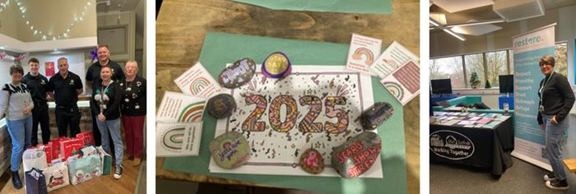

FINANCE MANAGER REPORT
Derek Gadd

I am pleased to report a solid improvement in the financial health of the Charity this year, achieved in tandem with an expansion of our outreach support services in West and Mid Suffolk. The result for the year to 31 March 2025 is an overall surplus of £41,548 providing a welcome restoration of reserves cover after the challenges of the previous year to March 2024.
A great deal of resource has been applied to grant funding applications with some success; income from those sources has increased three-fold compared to the previous year. Just as pleasing is the level of support given to the Charity from the public, and local companies and organisations; donation and legacy income, rose by 78% due in no small part to generous gifts in kind and a wonderful legacy of £28,000 received in March 2025, for all of which we are very grateful.
Medium term core funding both for refuge support and outreach services in Bury St Edmunds is secure. Suffolk County Council Public Health Directorate fund refuge support services under a contract which commenced in April 2023 for a minimum term of 3 years. In addition, core funding for outreach services from Suffolk Police and Crime Commissioner has been granted until March 2026. The Charity has also benefitted from medium term grant funding support from Lloyds Bank Foundation, BBC Children in Need and Masonic Charitable Foundation.
Whilst inflationary pressures have eased the operational environment remains challenging. In particular, staff costs have increased rapidly over the last few years and now comprise 66% of total expenditure. However, costs are carefully managed and, together with the generous support we continue to receive and the considerable work we put in to grow and diversify our sources of funding, the Charity is well placed to finance on-going service provision on a consistent basis.

We thank all who support our work, helping us deliver and enhance support to our clients. This year has been no exception with generous cash donations, Christmas gifts, toys, toiletries, clothes and Easter eggs. Every year we are overwhelmed by people’s generosity.

 | Income and expenditure for the 12 months to 31st March 2025 amounted to: |  |  |  |  |  | 2025 | 2024
 | Income |  |  |  |  |  | £535,741 | £352,149
 | Expenditure |  |  |  |  |  | £494,193 | £453,426
 | In the main refuge accommodation is funded from Housing Benefit which for 2024/25 amounted to £138,826 (2024: £130,033) on an occupancy rate for the year of 77% (2024: 77%), well below that budgeted. In addition, the Charity continues to receive financial support from Suffolk County Council Public Health Directorate for our Refuge services by way of a support grant of £94,816 (2024: £94,816).
 | Our outreach services and project work are mostly funded by grants and donations. Grant income amounted to £195,859 and comprised:
Grants |  |  |  |  |  |  |  |  |  |  |  |  |  |  | £
Suffolk Police & Crime Commissioner - Resource centre funding |  |  |  |  |  |  |  |  |  |  |  |  |  |  | 50,000
Lloyds Bank foundation - Unrestricted funding utilised for outreach |  |  |  |  |  |  |  |  |  |  |  |  |  |  | 25,000
Garfield Weston Foundation - core operational costs |  |  |  |  |  |  |  |  |  |  |  |  |  |  | 20,000
Suffolk Community Foundation - High Sherriff's Award - unrestricted |  |  |  |  |  |  |  |  |  |  |  |  |  |  | 1,500
Operation Santa Appeal - unrestricted |  |  |  |  |  |  |  |  |  |  |  |  |  |  | 1,500
Masonic Charitable Foundation - unrestricted |  |  |  |  |  |  |  |  |  |  |  |  |  |  | 5,000
Funding for Children's work and Young persons Support Project
BBC Children in Need - support staff and associated costs |  |  |  |  |  |  |  |  |  |  |  |  |  |  | 29,280
Tesco's Stronger Starts - Young person's programmes |  |  |  |  |  |  |  |  |  |  |  |  |  |  | 1,125
Kelly Family Foundation - Children's programmes |  |  |  |  |  |  |  |  |  |  |  |  |  |  | 5,000
Funding for Haverhill Outreach Project:
Haverhill Town Council |  |  |  |  |  |  |  |  |  |  |  |  |  |  | 400
West Suffolk Council - Councillors' Locality Budgets |  |  |  |  |  |  |  |  |  |  |  |  |  |  | 1,250
Funding for new Community Hubs (pilot projects):
West Suffolk Council - Community Chest Grant |  |  |  |  |  |  |  |  |  |  |  | Newmarket |  |  | 20,300
West Suffolk Community Safety Community Partnership |  |  |  |  |  |  |  |  |  |  |  | Stowmarket |  |  | 17,354
Stowmarket Town Council - Stow Fund |  |  |  |  |  |  |  |  |  |  |  | Stowmarket |  |  | 1,000
Funding for other projects:
West Suffolk Council - Councillors' Locality Budgets |  |  |  |  |  |  |  |  |  |  |  | Counselling |  |  | 5,500
Suffolk County Council (£6,000 over 2 fiscal years) |  |  |  |  |  |  |  |  |  |  |  | Counselling |  |  | 2,310
West Suffolk Community Safety Community Partnership |  |  |  |  |  |  |  |  |  |  |  | Counselling |  |  | 7,915
West Suffolk Council - Councillors' Locality Budgets |  |  |  |  |  |  |  |  |  |  |  | Book printing |  |  | 1,050
Suffolk Community Foundation Household Support Fund |  |  |  |  |  |  |  |  |  |  |  | Unrestricted |  |  | 375
 |  |  |  |  |  |  |  |  |  |  |  |  |  |  | £195,859
Donations received throughout the year amounted to £84,151 including Gift Aid. These are broken down as follows;
 |  |  |  |  |  |  |  |  |  |  |  |  |  |  | £
Restricted Donations |  |  |  |  |  |  |  |  |  |  |  |  |  |  | 21,217
Unrestricted Donations |  |  |  |  |  |  |  |  |  |  |  |  |  |  | 61,691
Gift Aid |  |  |  |  |  |  |  |  |  |  |  |  |  |  | 1,243
 |  |  |  |  |  |  |  |  |  |  |  |  |  |  | £84,151
Gifts in kind
During the year the Charity received generous gifts in kind which have been valued and included in the financial statements as part of restricted donations as follows:

 |  |  |  |  |  |  |  |  |  |  |  |  |  |  | £
Mrs Tina Dye |  |  |  |  |  |  |  | Refuge furniture |  |  |  | (capital) |  |  | 1,818
Whitewater Creative Limited |  |  |  |  |  |  |  | Charity rebranding |  |  |  | (capital) |  |  | 4,000
Mr Christopher Allen |  |  |  |  |  |  |  | Website construction |  |  |  | (capital) |  |  | 5,678
Foley House, Newmarket |  |  |  |  |  |  |  | Venue hire without charge |  |  |  | (revenue) |  |  | 3,400
Mrs Anna Russell |  |  |  |  |  |  |  | Clinical supervision |  |  |  | (revenue) |  |  | 2,210
 |  |  |  |  |  |  |  |  |  |  |  |  |  |  | £17,106
The Charity is very fortunate to receive many gifts in kind each year mostly for our service users and most of modest monetary value. Individual gifts valued at under £200 are not included in these financial statements.
Intangible income - Voluntary staff
The charity remains dependent on services provided by volunteers. Without these volunteers, wage costs would be much higher, and we are very thankful for the time volunteers give to the Charity.
The value provided by volunteers is not costed for the purposes of these financial statements.
Reserves Policy
The Charity's reserve policy is to hold unrestricted net current asset reserves equivalent to 3.5 to 5.5 months of projected operating costs to cover any temporary shortfall in cash flow that may occur due to the timing of receipts. Whilst the general economic backdrop continues to be challenging, the policy has been reviewed and left unchanged for the ensuing year.
Unrestricted net current assets at the end of the financial year were £165,418 (2024: £146,513), and reserves cover was 3.5 months being a modest increase in that held at March 2024 (3.2 months) and at the lower threshold of the policy range.
Auditor
Bury St Edmunds Women’s Aid’s accounts are audited by Knights Lowe of Bury St Edmunds and it is proposed that the Charity continues to use their services as auditor.
Future Plans
Primarily the organisation aims to ensure that current services are fully funded in the medium term, and we are able to increase our capacity to deliver those services.
Whilst the current economic outlook continues to present funding challenges, the ever increasing demand for domestic abuse support services compels us to continue to look for opportunities to extend the geographical reach of our adult outreach and develop our work with children and young people, subject to sufficient resources being available.
As always, I thank my colleagues and our trustees who have supported me in my role this year.

FEEDBACK
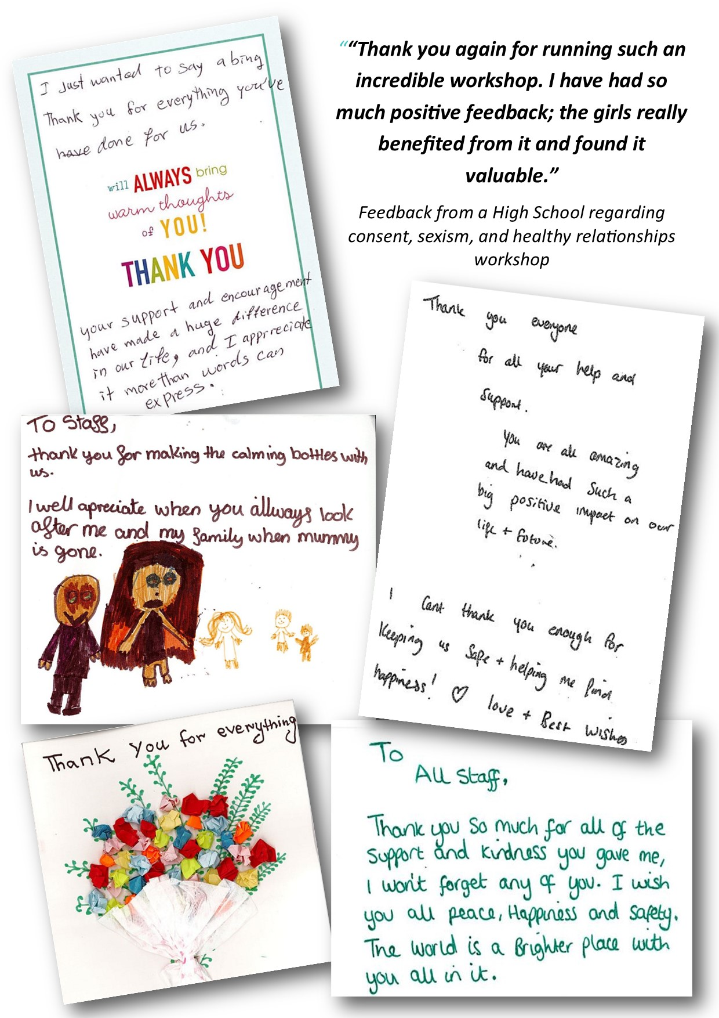

ACKNOWLEDGEMENTS
A huge thank you to all of our supporters, big and small, local and further afield, who have donated money, time and many lovely items:

Our Volunteers
AIS UK
Asda
Aquarius Singers
Bridge Church
Bury St Edmunds Lions
Bury St Edmunds Rotary
Bury St Edmunds Town Council & Councillors'
Children In Need
Clare Priory
Culford School
David Lloyd Bury St Edmunds
Donna Higgins & family
Gatehouse
Gee Gee’s Ranch
Gordon McMeechan
Green Light Trust
Haverhill Fire Station
Haywards Solicitors
HC3
Ickworth House
Knights Lowe
Lloyds Bank Foundation for England & Wales
Love Grace
Marks and Spencer
Margaret Healey & the Sisters of St Louis
Mothers Union
National Lottery
Newmarket Fire Station
Newmarket Town Council
No.5 Angel Hill Coffee Shop
REACH
Realise Futures
Rickshaw Riders
Round Table
Stuart and Christine Samuels (Father and Mrs Christmas!)
Suffolk Community Foundation
Suffolk County Council Public Health Directorate
Suffolk Police and Crime Commissioner
Tesco
The Buckingham Emergency Food Appeal
BEFA
Theatre Royal
Toolbox
Tys 2024
Unite the Union
Vineyard Church
Waitrose
West Suffolk Council
Women’s Institute
Wooster’s Bakery
and many many more!!

We would also like to thank our donors who choose to remain anonymous. Without the continued support of our donors, we would not be able to offer the high level of services and support to the people that need them.

DONORS AND SPONSORS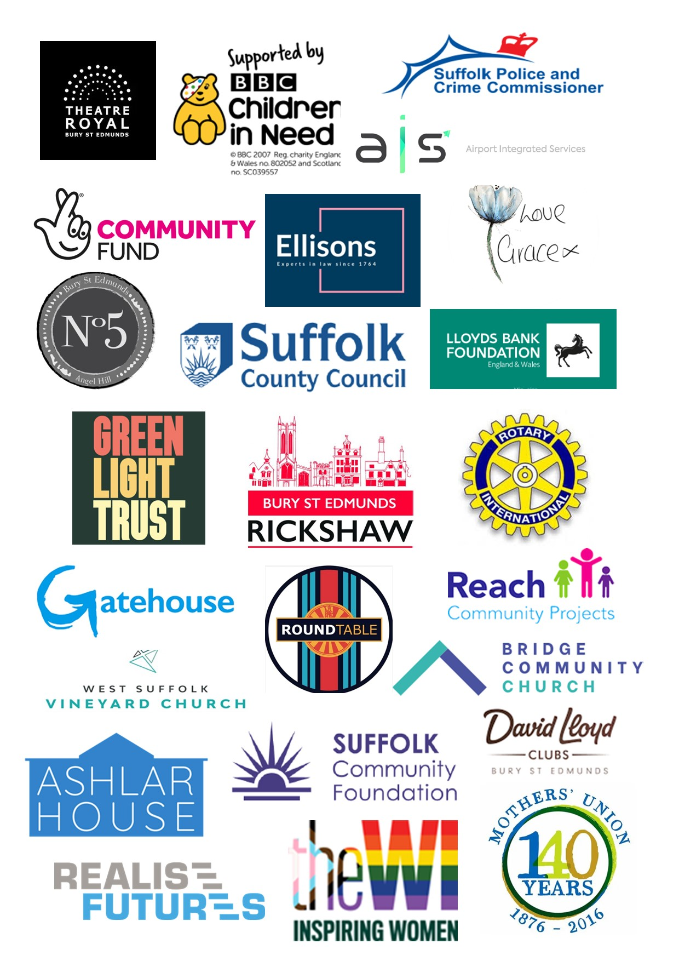

Stay up to date with our news and events at:
www.restore-wa.org.uk
Instagram: https://www.instagram.com/restorewa/
Facebook: https://www.facebook.com/BSEwomensaid

SPEAKING ENGAGEMENTS
Interested in hearing more about our work? We are happy to provide a speaker for your organisation or group, please email at admin@restore-wa.org.uk.

CURRENT SERVICES
We provide many services which are accessed by women from the local community and from outside Suffolk:
20-bed Refuge
Telephone Advice Helpline | Resettlement Support
Outreach Service | Child Centred Groups
Freedom Programme  VOICE | Adult Counselling Service  Young People Service
Survivors of Domestic Abuse (SODA)  Male Victim Support | Coffee Morning (Bury St Edmunds, Haverhill, Stowmarket and Newmarket)
Advice Helpline: 0330 551 9495
Restore-wa.org.uk
Post: PO Box 715, Bury St Edmunds, IP33 9HQ

